Name: Rameen Roll No: 2023-EE-03
EE-322L Analog and Digital Communication Marks Obtained: ________
Lab Report
Experiment No. 8
FM Demodulation using PLL

- Objective
In this Laboratory exercise you will demodulate a frequency modulated signal using PLL which you have generated in lab 7.

- Technical Background
The technical background for Experiment No. 8, FM Demodulation using PLL, is based on the principles of Frequency Modulation (FM) and the use of a Phase-Locked Loop (PLL) as a frequency-tracking demodulator and frequency-to-voltage converter.

FM Demodulation:
Frequency Demodulation is the process of extracting the original message signal m(t) from a received FM signal.
- In an FM signal, information is encoded in the instantaneous frequency.
- The instantaneous frequency $f_{i}$(t) varies with the message signal amplitude:
$f_{i}$(t) = $f_{c}$ + $k_{f}$m(t)
where $f_{c}$is the carrier frequency and $k_{f}$​ is the frequency deviation constant.
- To recover the message, the demodulator performs frequency-to-voltage (F/V) conversion, producing a voltage that is proportional to the instantaneous frequency of the FM signal.
Phase-Locked Loop (PLL) as an FM Demodulator
A PLL is ideal for FM demodulation because it can track the frequency of an incoming signal. The PLL is a feedback control system consisting of three main blocks: Phase Detector (PD), Low-Pass Filter (LPF), and Voltage-Controlled Oscillator (VCO).

Demodulation Mechanism
The PLL demodulates FM signals using its negative feedback loop:
- Phase Tracking: The PLL is locked to the unmodulated carrier frequency $f_{c}$
- Frequency Deviation: The input FM signal has an instantaneous frequency that varies according to m(t).
- VCO Correction: The VCO frequency continuously adjusts to maintain phase lock with the input $f_{i}$(t).
- Signal Recovery: The PD produces an error signal proportional to the frequency difference, and the LPF converts it into a smooth control voltage. This voltage forces the VCO to track the input frequency.
- Output: The voltage across the LPF is proportional to the frequency deviations and represents the recovered message signal m(t), while high-frequency components are suppressed.

Advantages of PLL Demodulation
- High Linearity: Determined by the VCO's voltage-to-frequency characteristic.
- Noise Immunity: FM signals are less sensitive to amplitude noise, and the PLL tracks frequency, reducing noise effects.
- Low Distortion: Minimal distortion makes PLL demodulators suitable for high-fidelity applications.

- Task-1
  - Description

Perform all steps given in previous lab manual to generate the Frequency modulated signal

  - Circuit, Design and Calculations
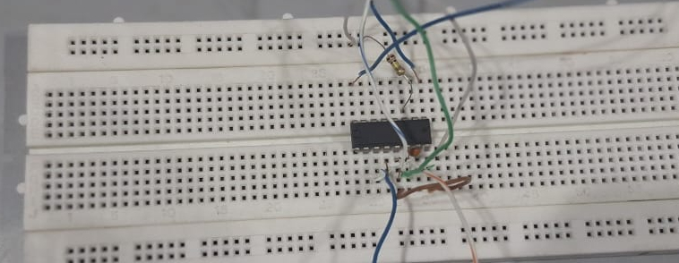
The following circuit was implemented:

  - Results and Discussions (with all graphs and snaps)
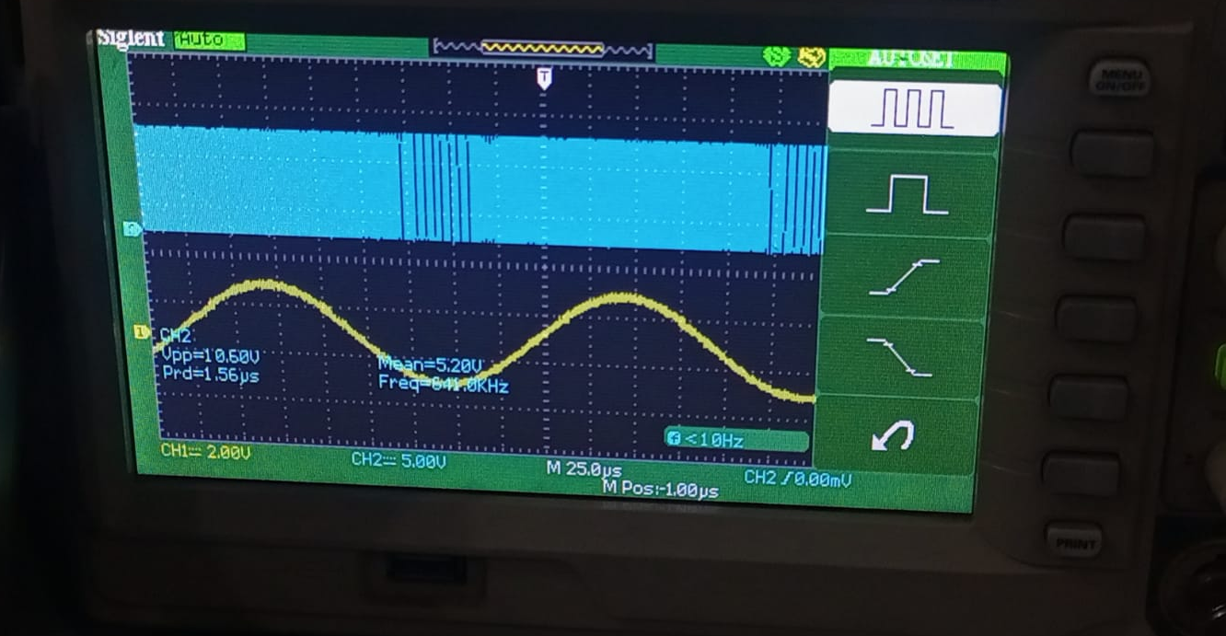

- Task-2
  - Description
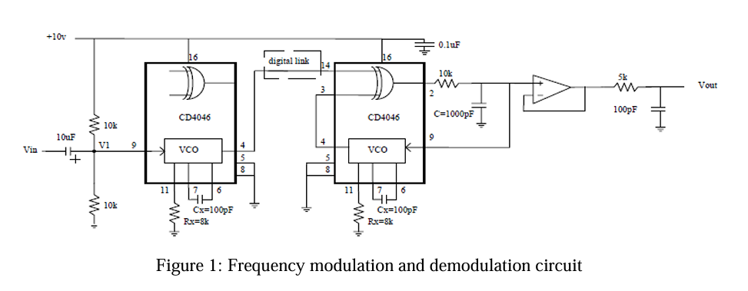
First PLL IC CD4046 is used for FM modulation and second CD4046 is used for demodulation of FM modulated signal. Build the circuit shown in Figure 1 for FM modulation and demodulation. It is not necessary to use the buffer and output low pass filter. Show the spectrum of your FM demodulated signal to the instructor.

  - Circuit, Design and Calculations

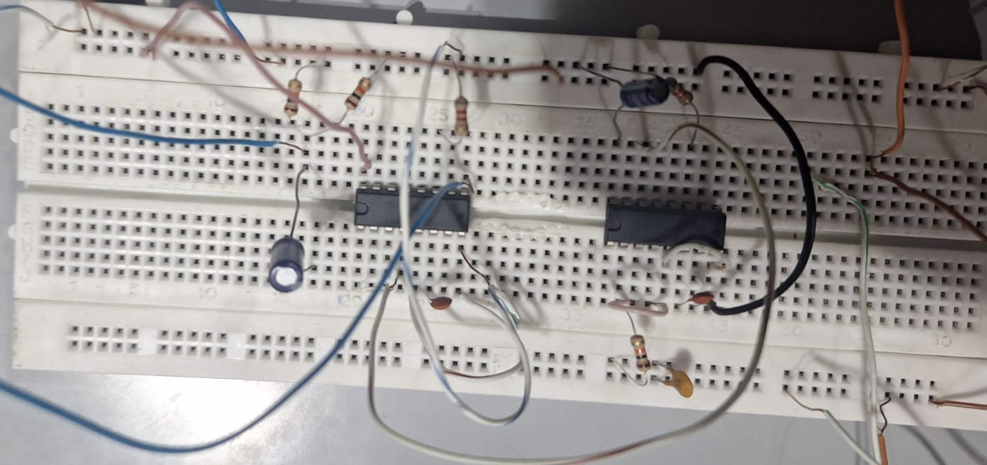

  - Results and Discussions (with all graphs, and snaps)
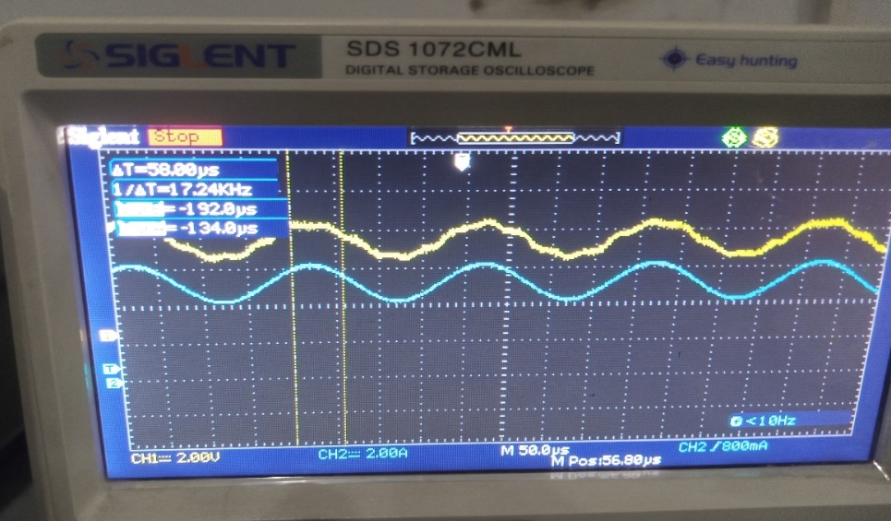
The blue signal is the message signal and the yellow signal is the demodulated signal.

- Conclusion

In this lab exercise, we generated and demodulated a frequency-modulated (FM) signal using two CD4046 Phase-Locked Loop (PLL) ICs—one for modulation and the other for demodulation. By following the steps from the previous lab to create an FM signal and then applying it to the demodulation circuit, we were able to retrieve the original message signal.
The demodulated output showed that the PLL could effectively track the frequency variations in the FM signal and convert them back into amplitude variations, replicating the original input message. Observing the output spectrum confirmed that the PLL successfully locked onto the FM signal and accurately reproduced the modulation signal. This experiment highlights the PLL’s practical utility for FM demodulation and provides insight into the frequency-to-amplitude conversion principle fundamental to FM demodulation applications in communication systems.
Overall, this lab deepened our understanding of PLLs in both modulation and demodulation processes and demonstrated their effectiveness in handling frequency-modulated signals.

Rubrics for Experiment No.7

Performance | Exceeds expectation (2)/(1) | Meets expectation (1)/(0.5) | Does not meet expectation  (0.5)/(0) | Marks
R1: Realization of Experiment’s Hardware on Breadboard.  Marks: 0-1 | The circuit is patched correctly, and safely, with neat  connections on the breadboard | The circuit is  patched neatly and correctly, but not in a workable form | Incapable to patch the circuit correctly and  neatly on breadboard
R2: Knowledge of theoretical aspects  Marks: 0-2 | Has theoretical knowledge required for the experiment | Has partial theoretical knowledge about the experiment | Has no background knowledge about the experiment
R3: Conducting Hardware  Experiment.  Marks: 0-1 | All the required tasks are correctly implemented | The required tasks are partially implemented | Unable to implement all the tasks even with guidance
R4: Demonstrate proper results with justification.  Marks: 0-2 | Correct results are provided with required justification | Results are provided with  minor errors and/or with little  justification | Results are provided with major errors  and/or with no justification

Rubrics for Lab Manual No.7

Performance | Exceeds expectation (0.5)/(0.25) | Meets expectation (-)/(-) | Does not meet expectation (0)/(0) | Marks
R1: Timely submission  Marks: 0-  0.25 | The submission is on  time | --- | Late submission
R2: Report completenes s  Marks: 0-0.5 | All relevant calculations, specifications, code, graphs, and results are provided with proper  explanation. | All the relevant calculations,  specifications, code, graphs and results  are provided but with little  explanation and justification. | Most of the relevant graphs, results,  calculations, specifications, and code are missing, as well as their proper  explanation and  justification is also missing.
R3: Error-  free writeup  Marks: 0-  0.25 | The submitted  assignment is without any plagiarism and formatting errors. | Some parts of the submitted  assignment contain formatting errors and plagiarized material. | The submitted assignment is mostly plagiarized and contain formatting errors.

